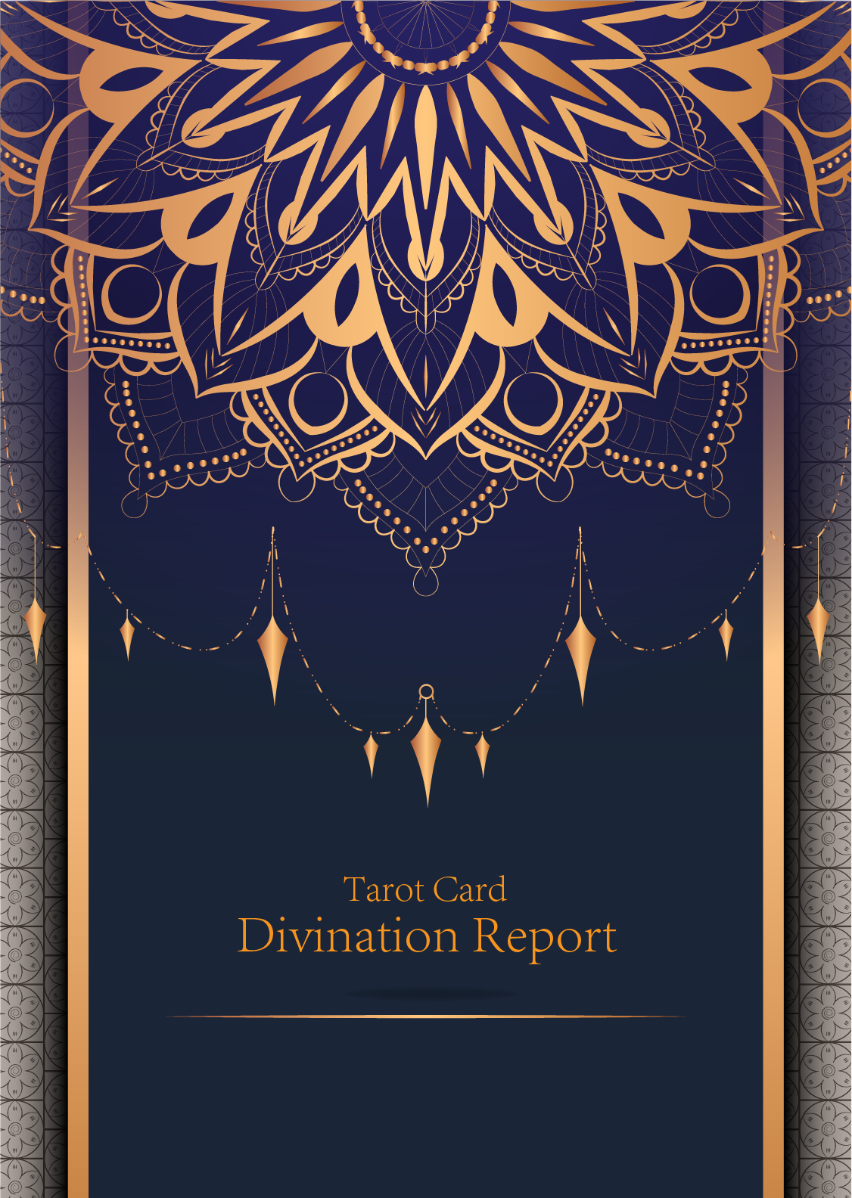

|  |
| --- |
| February 23, 2024 |

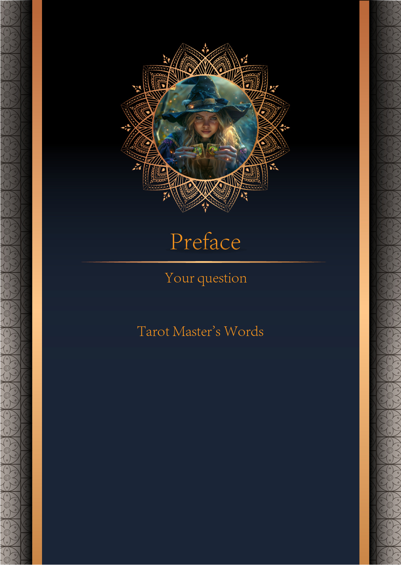

|  |
| --- |
| 我什么时候能结婚 |

|  |
| --- |
| Before we begin the interpretation, I would like to explain some important points to you. Tarot cards are not tools for predicting the future, but rather tools for guiding us to delve deeper into various situations in life. Therefore, when receiving the reading, please maintain an open mindset and trust your intuition. Our goal is to provide you with inspiration and guidance through the guidance of the tarot cards, helping you better deal with challenges and decisions in life. Alright, you can start reading now! |

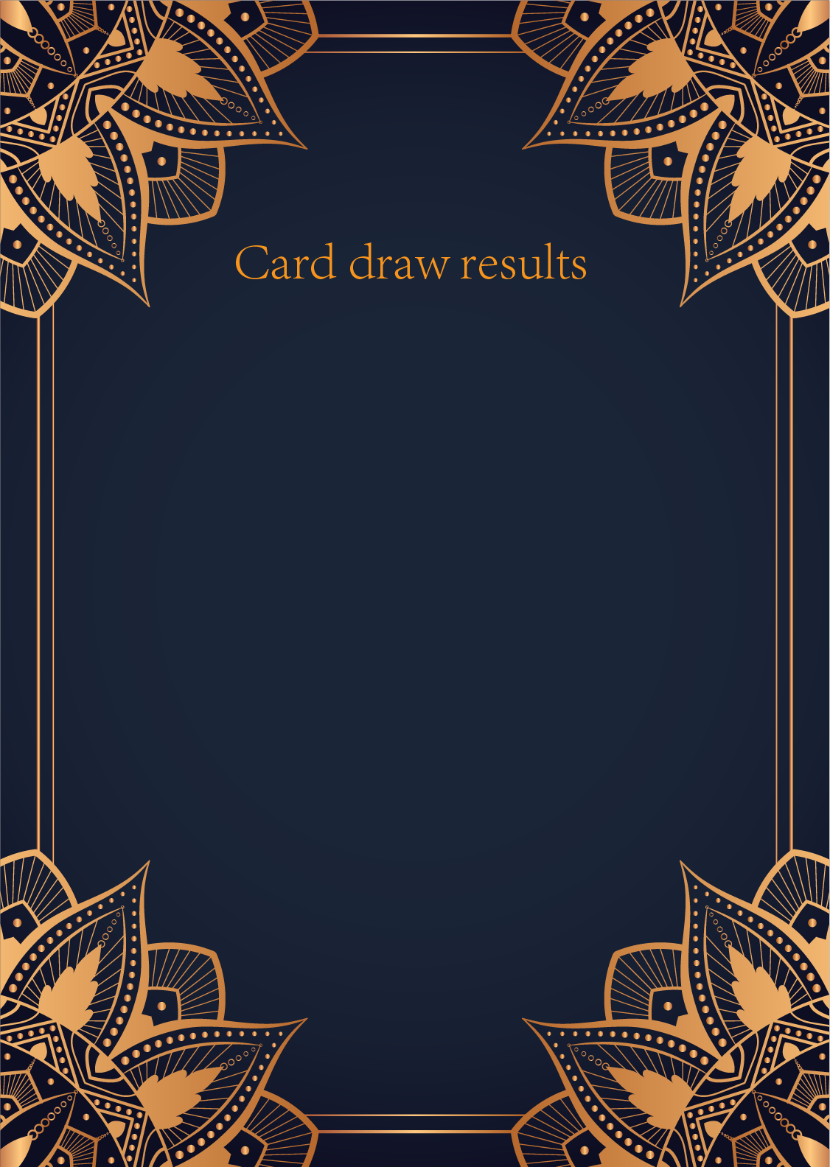

|  |
| --- |
| CardⅠ The Sun |
|  |
| The Sun card presents an feeling of optimism and fulfillment. This card represents the dawn which follows the darkest of nights. The Sun is the source of all the life on our planet, and it represents life energy itself. There is a child depicted in the card, playing joyfully in the foreground. A symbol of our innocence, it represents the happiness that occurs when you are in alignment with your true self. The child is naked, meaning that he has absolutely nothing to hide. The card also depicts the childhood innocence and absolute purity. This is particularly emphasized through the white horse upon which the child is riding. The horse here is also a symbol of strength and nobility. |

|  |
| --- |
| CardⅡ The Moon |
|  |
| When we encounter the Moon, we see a path that leads off into the distance. On either side of the path stand a wolf and a dog, representing our animalistic nature - one is civilized, and the other wild and feral. There is a crawfish that is crawling out of the pond from which the path stems from. In the distance, we can see two towers flanking the central path, once again alluding to the doubles visible in this card. Everything in this card seems to echo the other, as if to allude to two possibilities. When we walk down the path, we walk the fine line between conscious and unconscious, between the tamed side of civilization of the dog, and the forces of nature represented by the wolf. |

|  |
| --- |
| CardⅢ The Star |
|  |
| The Star card shows a woman kneeling at the edge of a small pond. She is holding two containers of water. One container pours the water out to the dry land, as if to to nourish it and ensure its fertility. The lush green land around her seems to say that it is working. One foot is inside the water which shows the spiritual abilities and inner strength of the woman. The other foot on the ground shows her practical abilities and strengths. Behind her, there is a large central star surrounded by seven small stars which represent the chakras. There is bird standing at a tree branch which represents the holy ibis of thought. The Star's astrological correspondent is Aquarius. |

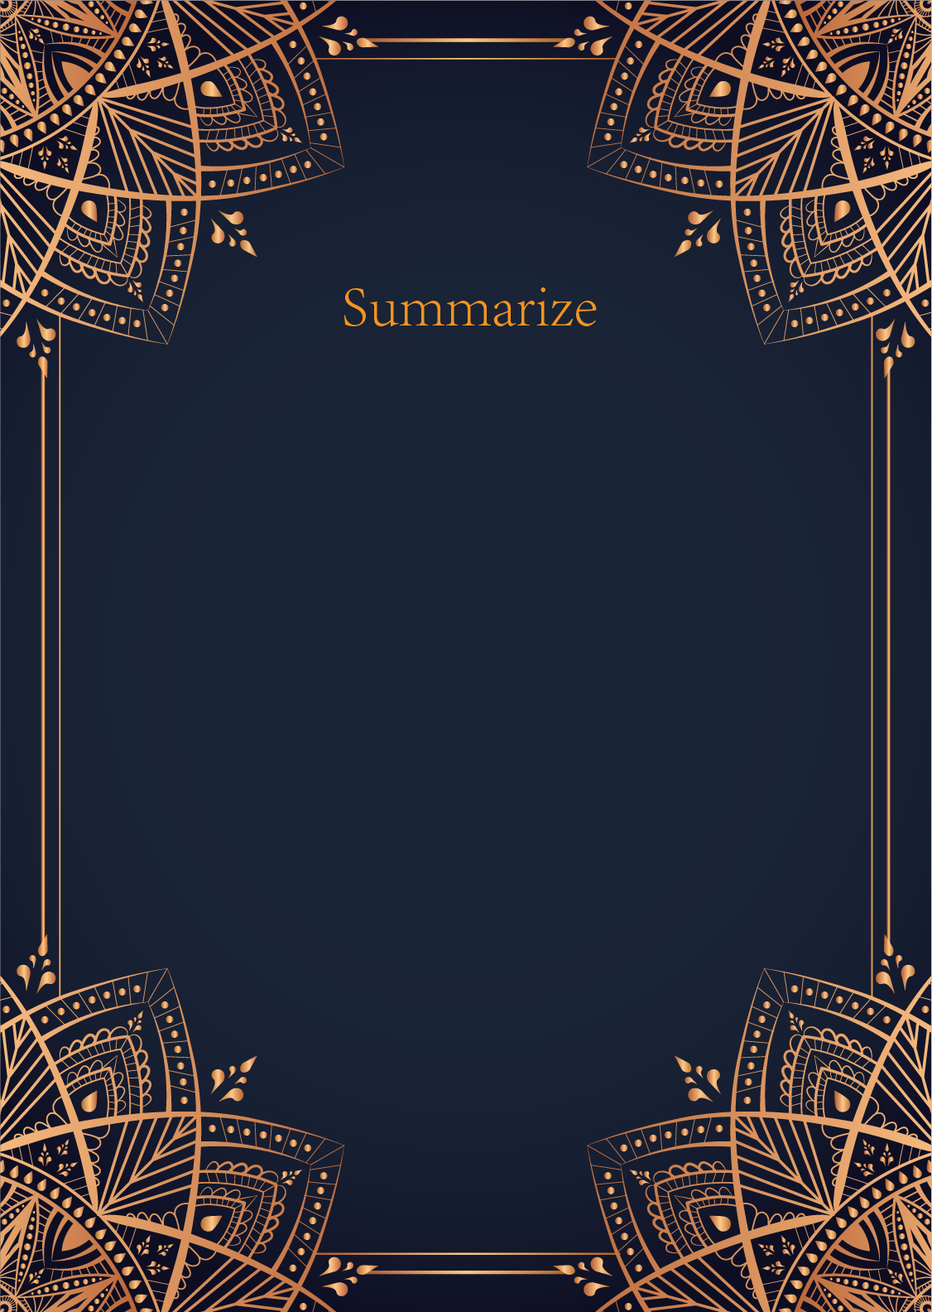

|  |
| --- |
| Ah, dear seeker, your question is one of love and union, a delicate dance of fate and timing. Let us delve into the mystical realm of the tarot to uncover the secrets that lie within the cards you have drawn.  The Sun, a card of joy, success, and fulfillment, shines brightly upon your inquiry. It speaks of a time of growth and happiness, a period where you are radiant with confidence and positivity. This card suggests that your journey towards marriage is filled with warmth and light, with opportunities for love and partnership blossoming in abundance.  The Moon, a card of intuition, dreams, and mystery, casts its ethereal glow upon your path to matrimony. It signifies a time of deep emotional exploration and introspection, where hidden truths are revealed and illusions are dispelled. This card urges you to trust your inner voice and follow the guidance of your heart as you navigate the complexities of relationships and commitments.  The Star, a card of hope, inspiration, and spiritual guidance, twinkles in the vast expanse of the night sky, offering you a beacon of light to guide you towards your desires. It symbolizes a period of optimism and faith, where your dreams and aspirations align with the cosmic forces to lead you towards a union that is written in the stars. This card encourages you to stay true to your authentic self and believe in the power of destiny to bring you to your destined partner.  In combining the energies of the Sun, the Moon, and the Star, we see a harmonious symphony of love and destiny unfolding in your life. The cards speak of a time of profound personal growth, emotional clarity, and spiritual alignment that will pave the way for you to find the love and partnership you seek. Trust in the journey, dear seeker, and let the radiant energies of the tarot guide you towards the sacred union you long for.  Remember, the timing of when you will marry is a dance between the forces of the universe and the desires of your heart. Stay open to the signs and synchronicities that come your way, and trust that the cosmic energies are aligning to bring you to the perfect moment of union. Love is a sacred journey, and as long as you remain true to yourself and your path, the universe will conspire to bring you the love and happiness you seek.  May the light of the Sun, the wisdom of the Moon, and the guidance of the Star illuminate your path towards a joyous and fulfilling marriage. Blessed be, dear seeker, may love and happiness be yours. |

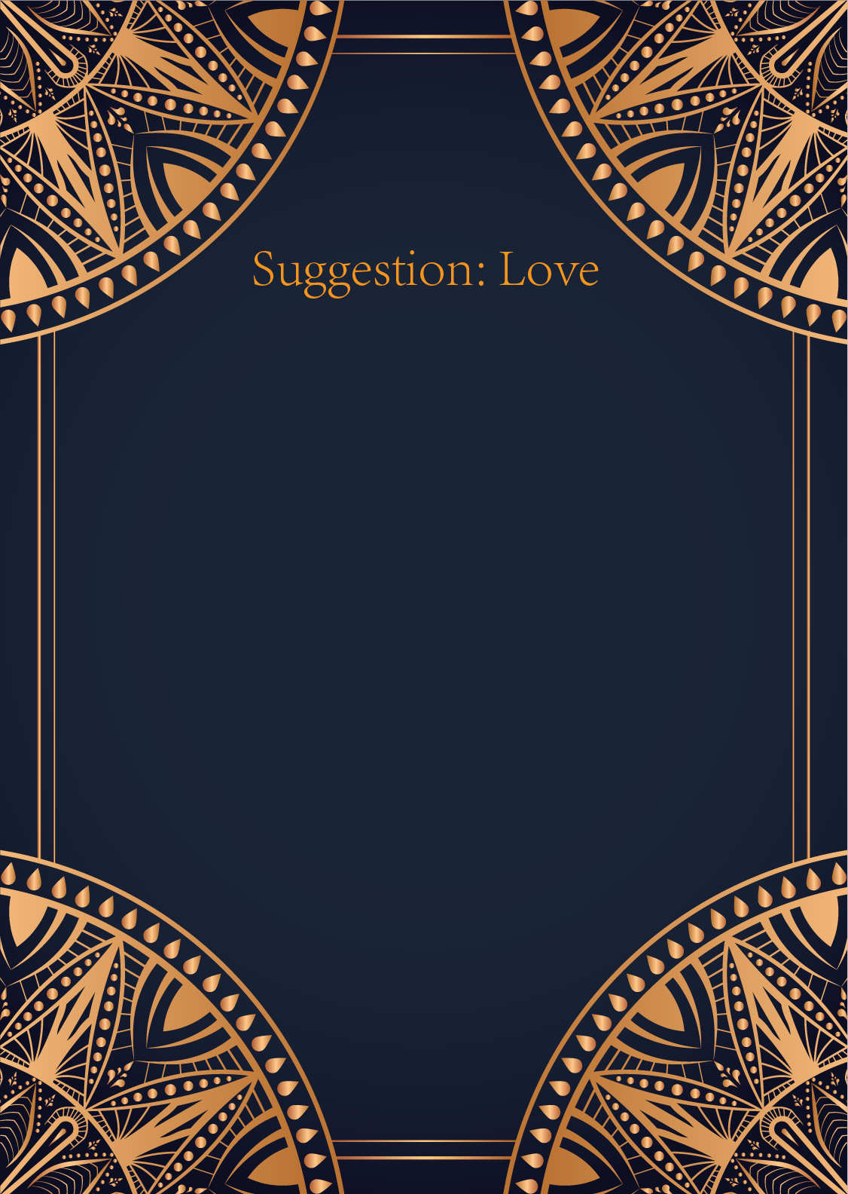

|  |
| --- |
| Ah, the Sun, the Moon, and the Star. What a powerful combination of cards for matters of the heart. The Sun speaks of joy, success, and fulfillment in love. It indicates a strong and radiant connection with your partner, full of warmth and happiness. It suggests that now is a time to embrace love with confidence and enthusiasm, basking in the glow of mutual affection.  The Moon, on the other hand, represents mystery, intuition, and emotional depth. It encourages you to listen to your innermost feelings and explore the deeper layers of your relationship. The Moon reminds you that love is not always straightforward, and there may be hidden truths or subconscious emotions at play. Trust your instincts and pay attention to your dreams and intuition when it comes to matters of the heart.  And finally, the Star, a card of hope, inspiration, and guidance. The Star shines brightly in the darkness, offering reassurance that love will always light the way. It suggests that you should have faith in the possibilities of love and remain optimistic about the future of your relationship. Allow yourself to dream big and envision a beautiful romantic journey ahead.  In essence, these three cards advise you to embrace the joy and positivity in your relationship (Sun), delve deep into your emotions and intuition (Moon), and remain hopeful and inspired about the future (Star). Remember to communicate openly with your partner, trust your instincts, and keep the flame of love burning bright. Love is a journey, and with these cards as your guide, may your path be filled with light, magic, and endless possibilities. |

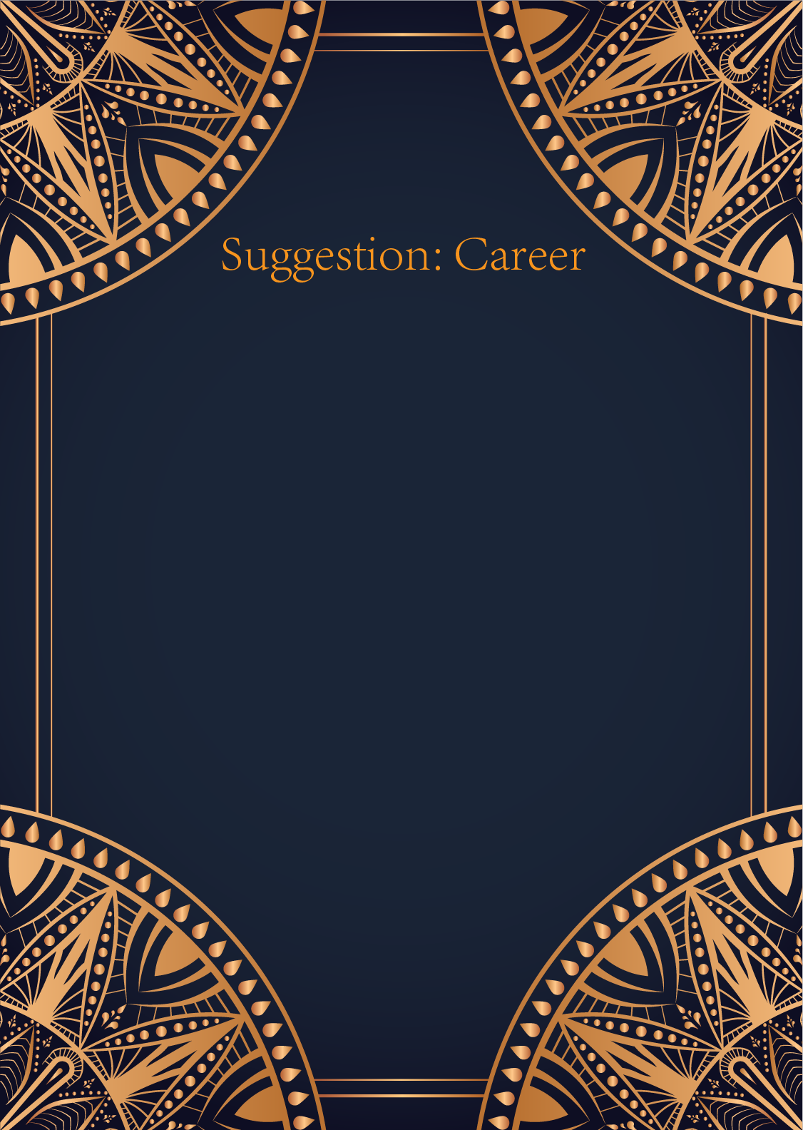

|  |
| --- |
| Ah, the Sun, the Moon, and the Star, what a powerful trio of cards you have drawn. Together, they shine a light on your career path and offer guidance for your professional journey.  The Sun represents success, vitality, and abundance. It encourages you to embrace your strengths and talents, and to radiate confidence in your abilities. In your career, this card urges you to step into the spotlight, take on leadership roles, and pursue projects that bring you joy and fulfillment. Embrace new opportunities with optimism and enthusiasm, and let your light shine brightly for all to see.  The Moon, on the other hand, speaks to intuition, mystery, and the subconscious mind. It urges you to trust your instincts and listen to your inner voice when making career decisions. Pay attention to your dreams and emotions, as they may hold valuable insights into the path you should follow. The Moon also reminds you to be adaptable and flexible in your career journey, as success may come from unexpected places and opportunities.  Lastly, the Star symbolizes hope, inspiration, and guidance. It serves as a beacon of light in times of darkness, encouraging you to stay true to your dreams and aspirations. In your career, the Star advises you to set ambitious goals, aim for the stars, and believe in your own potential to achieve greatness. Trust that the universe is guiding you towards your true calling, and have faith in the path that lies ahead.  Overall, these cards suggest that you are on the right track in your career endeavors. Continue to embrace your strengths, trust your intuition, and never lose sight of your true aspirations. Remember to stay positive, remain open to new possibilities, and let your inner light guide you towards success. The universe is on your side, dear one, so embrace the journey ahead with confidence and grace. |

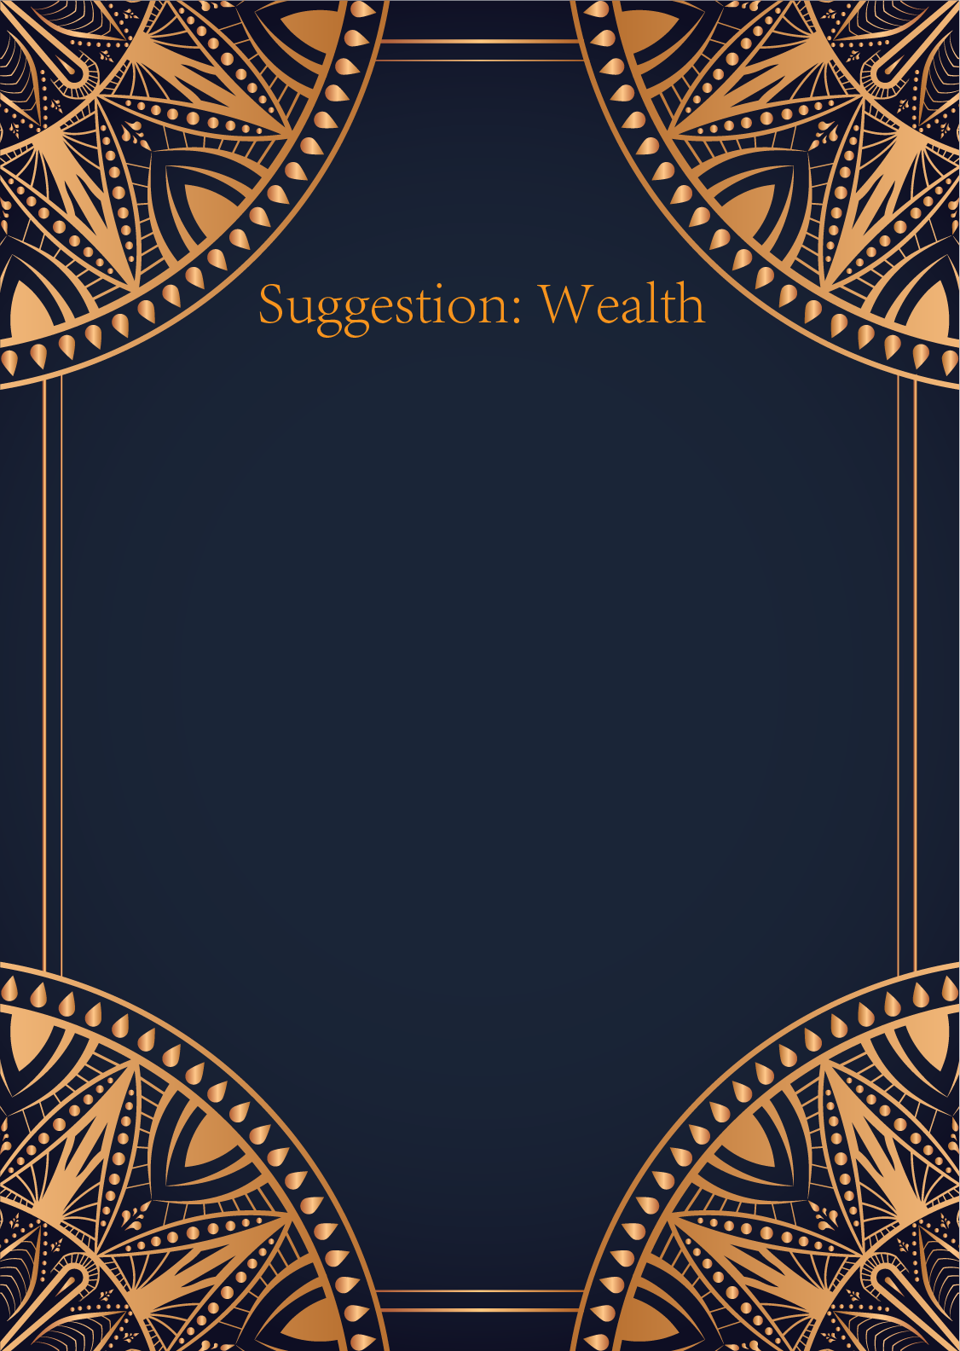

|  |
| --- |
| Ah, the Sun, the Moon, and the Star. A powerful trio of cards indeed, symbolizing abundance, intuition, and hope in the realm of finances. The Sun brings you clarity and success in your financial endeavors, illuminating the path to prosperity. It signifies a period of growth and abundance, where your hard work will be richly rewarded.   The Moon, on the other hand, urges you to trust your intuition when it comes to money matters. Listen to your inner voice and pay attention to your dreams and subconscious messages. There may be hidden factors or opportunities that you need to explore, so stay open and receptive to the universe's guidance.  And finally, the Star shines brightly above you, offering you hope and inspiration in times of financial uncertainty. It reminds you to stay optimistic and have faith in the abundance of the universe. Trust that your financial goals are within reach, and keep your focus on your long-term vision.  To combine the energies of these cards, my advice to you is this: embrace the brightness of the Sun by setting clear financial goals and working diligently towards them. Trust your intuition like the ever-changing phases of the Moon, and be open to new opportunities that may not be immediately apparent. And let the guiding light of the Star inspire you to stay hopeful and optimistic, even in challenging times.  Remember, wealth and abundance are not just about money, but also about feeling fulfilled and aligned with your true purpose. Trust in the journey, and believe that the universe is conspiring in your favor. Brighter days are ahead, dear seeker. Embrace the energies of the Sun, Moon, and Star, and may your financial path be filled with abundance and joy. |

